 

**Hard and Soft 2018**

**Remote, No Moving Parts, Weather Station**

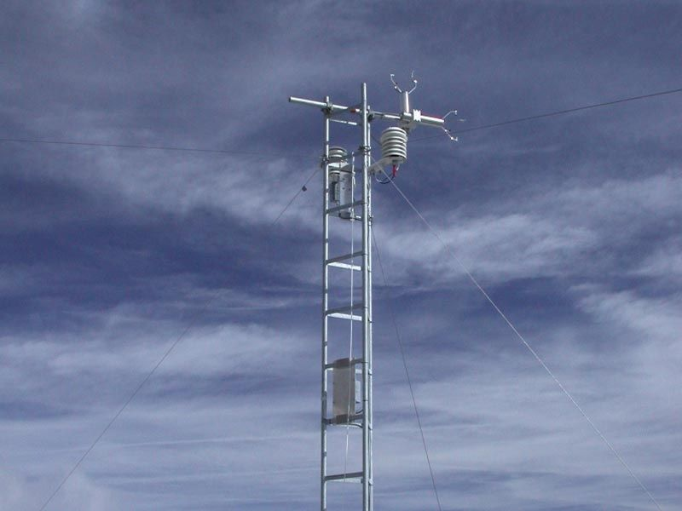

**Timisoara Team 2**

We build a basic system, recording temperature, humidity, and barometric pressure that sends its data for display to an App on an Android smartphone by Bluetooth. We use ESP32 as a main subsystem which takes data like temperature, humidity and atmospheric pressure from BME280 on I2C . The values received from BME280 are processed and sent via bluetooth to android application.

Security is a key aspect of our design, the hardware connections between the ESP32 and sensors are inherently secure from an unwanted third party, the Bluetooth communication with the mobile smarthphone application is crypted, the module will only pair with a particular MAC address and just to be sure we will add an ID to the frames sent via Bluetooth and every message with a wrong ID will be discarded.

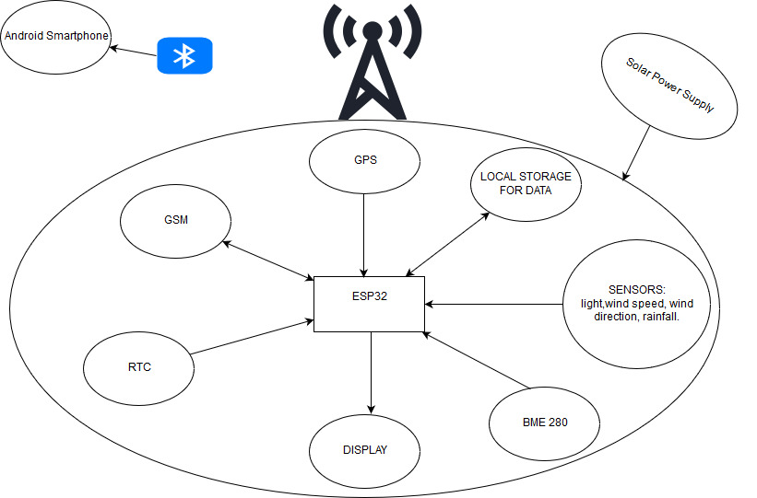

**Android Application**

**Our android application search for BLE devices and connect to the selected BLE device from the list displayed. Application also displays data received from the BME 280 sensor like temperature , humidity and atmospheric pressure.**

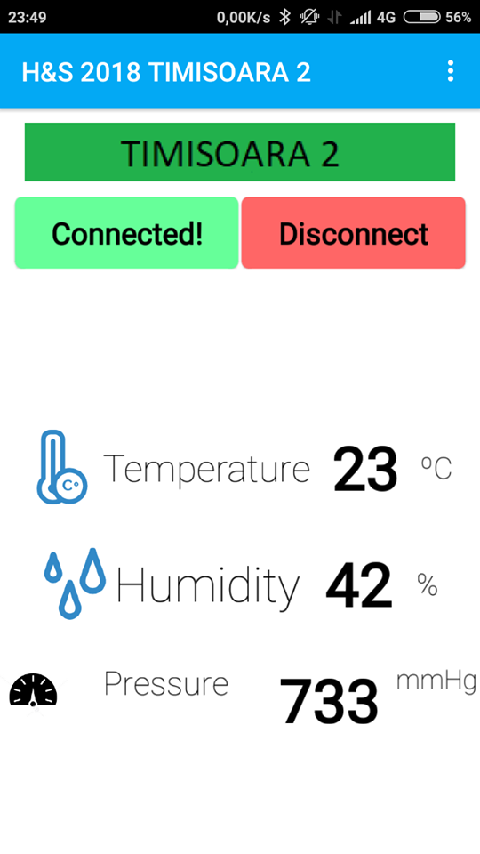

**Versioning our work**

**We use Git to keep our work safe and for tracking changes in our files and coordinating work on those files between us . As a Git application we use GItKraken. We create a repository in GitHub and every member of the team clone this repository and use GitKraken to push their changes.**

